Documentation with screenshots for Application.

**User Story 1:**

Step 1:

The data to be loaded into a data store from exchange rates API.

The below is the code snippet which is connected to H2 data base.

Following is the Controller class.

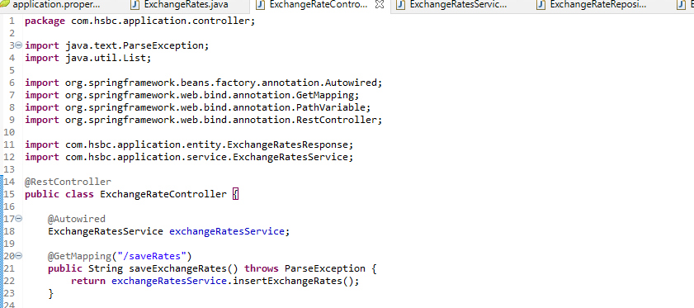

The service Class and Repository class shows below:

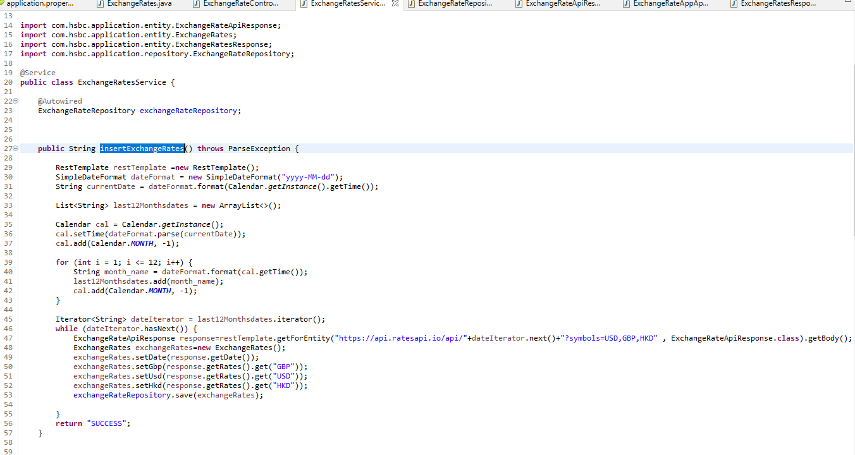

Following is the H2 Data base which is displaying the last 12 months with 12 rows in database.

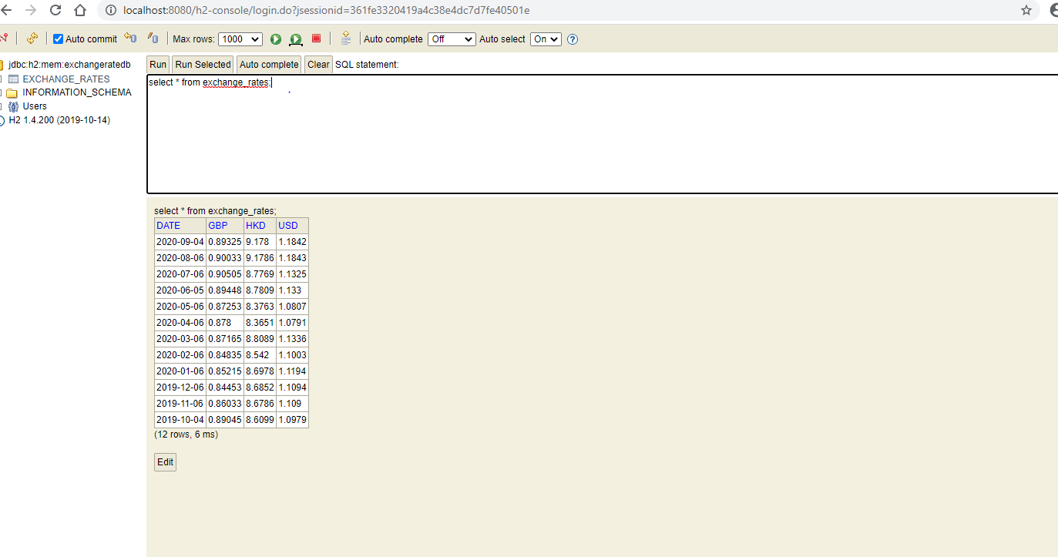

**User Story 2:**

Exposing Data

Step 1:

Rest endpoint is created Following is the controller class.

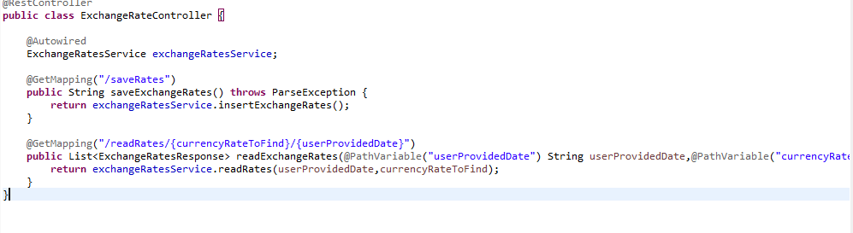

Step 2:

Following is the service class and repository class.

Service Class:

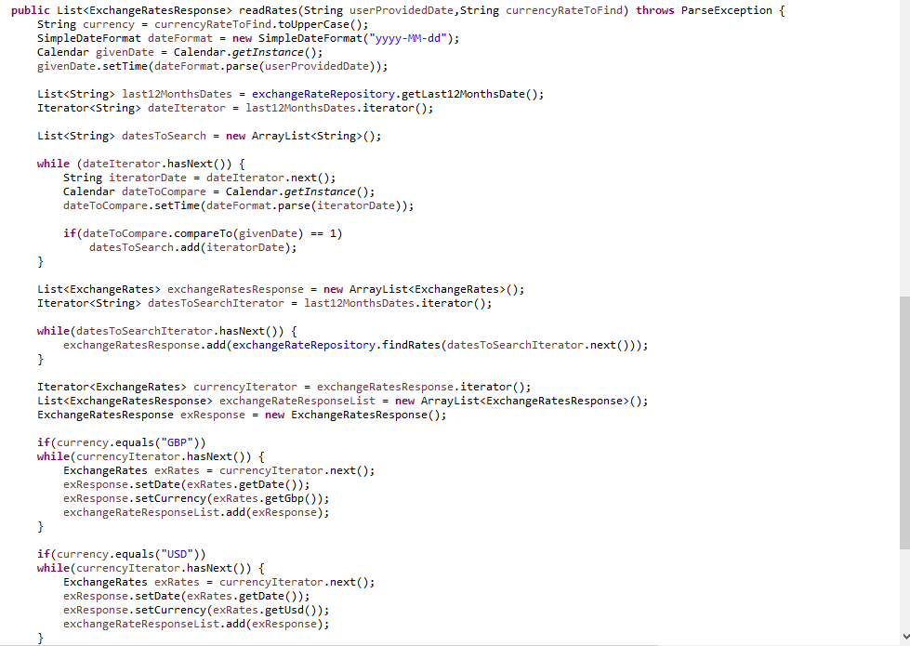

Repository Class:

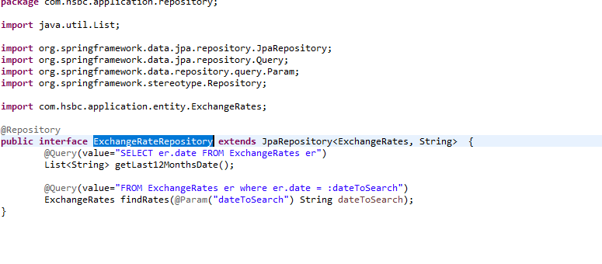

Step 3:

Following are the outputs which returns json format for GBP,USD,HKD.



